**Assignment-4**

Name :- Bibek Chand Sah

Roll No. :- 22054029

Section :- CSE-05

1. WAQ to display the current date.

🡺 SELECT SYSDATE AS current_date FROM dual;

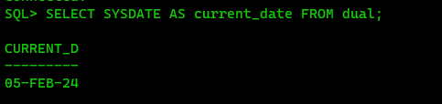

2. Assume that employees serve a six month provisional period starting from their DOJ. After 6 months they get permanent status. Display all the employees’ names, doj and the date on which they received their permanent status as permanent_date.

🡺 SELECT f_name, l_name, doj, doj + INTERVAL '6' MONTH AS permanent_date FROM employee;

3. WAQ to display the last date of this current month.

🡺 SELECT LAST_DAY(SYSDATE) AS last_date_of_month FROM dual;

4. For all the employees display their emp_id, f_name and their total experience in months.

🡺 SELECT employee_id, first_name, last_name, MONTHS_BETWEEN(SYSDATE, doj) AS total_experience_months FROM employee;

5. WAQ to display the date of next TUESDAY.

🡺 SELECT NEXT_DAY(SYSDATE, 'TUESDAY') AS next_tuesday_date FROM dual;

6. WAQ to extract the current month.

🡺 SELECT EXTRACT(MONTH FROM SYSDATE) AS current_month FROM dual;

7. WAQ to extract the current year.

🡺 SELECT EXTRACT(YEAR FROM SYSDATE) AS current_year FROM dual;

8. WAQ to display the absolute value of -505.

🡺 SELECT ABS(-505) AS absolute_value FROM dual;

9. WAQ to display the ceiling of 10.44 and 10.50 and 10.65.

🡺 SELECT CEIL(10.44) AS ceil_1, CEIL(10.50) AS ceil_2, CEIL(10.65) AS ceil_3 FROM dual;

10. WAQ to display the floor value of 10.44 and 10.50 and 10.65.

🡺 SELECT FLOOR(10.44) AS floor_1, FLOOR(10.50) AS floor_2, FLOOR(10.65) AS floor_3 FROM dual;

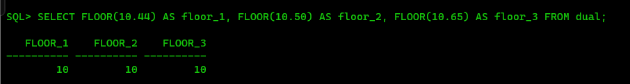

11. Find the logarithmic value of 10 base 2.

🡺 SELECT LOG(10, 2) AS logarithmic_value FROM dual;

12. Display the remainder in 594/7.

🡺 SELECT MOD(594, 7) AS remainder FROM dual;

13. WAQ to display the value of 8 to the power 3.

🡺 SELECT POWER(8, 3) AS power_value FROM dual;

14. WAQ to display the square root of 3481.

🡺 SELECT SQRT(3481) AS square_root FROM dual;

15. Display the following rounding operations- round(45.923,2), round(45.923,0), round(45.923,-1), round(45.923,2), round(45.923,0), round(45.923,-2).

🡺 SELECT ROUND(45.923, 2) AS round_1, ROUND(45.923, 0) AS round_2, ROUND(45.923, -1) AS round_3, ROUND(45.923, -2) AS round_4 FROM dual;

16. Display the following rounding operations- trunc(45.888,2), trunc(56.758,0), trunc(49.245,-2), trunc(45.888,2), round(45.888,2).

🡺 SELECT TRUNC(45.888, 2) AS trunc_1, TRUNC(56.758, 0) AS trunc_2, TRUNC(49.245, -2) AS trunc_3 FROM dual;

17. WAQ to return the sign of 20 and -67.60 and 0.

🡺 SELECT SIGN(20) AS sign_1, SIGN(-67.60) AS sign_2, SIGN(0) AS sign_3 FROM dual;

18. Display the value of cos(45), sin(45), and tan(45).

🡺 SELECT COS(45) AS cosine, SIN(45) AS sine, TAN(45) AS tangent FROM dual;

19. Display the ASCII character corresponding to the integer 79.

🡺 SELECT CHR(79) AS ascii_character FROM dual;

20.Display the f_name and l_name together using the concat() function.

🡺 SELECT CONCAT ('Bibek', 'Sah') FROM DUAL;

21. Display all the f_names in capital letters.

🡺 SELECT UPPER(first_name) AS capital_f_name FROM employee;

22. Find the length of the first name and last name of all the employees who work in the sales department.

🡺 SELECT LENGTH(first_name) AS first_name_length, LENGTH(last_name) AS last_name_length FROM employee WHERE dept = 'sales';

23. Determine the tax-rate for each employee based on their monthly salary. The tax-rates are

as per the following table. If salary is < 2000 then tax rate is 0 %, 20000<=salary<40000 9%, 40000<=salary<60000 20%, 60000<=salary<80000 30%, salary>=80000 45%

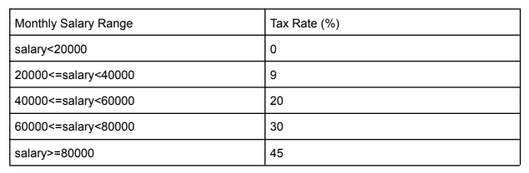

🡺 SELECT employee_id, first_name, last_name, salary, CASE WHEN salary < 2000 THEN 0 WHEN salary >= 20000 AND salary < 40000 THEN 9 WHEN salary >= 40000 AND salary < 60000 THEN 20 WHEN salary >= 60000 AND salary < 80000 THEN 30 WHEN salary >= 80000 THEN 45 END AS tax_rate FROM employee;

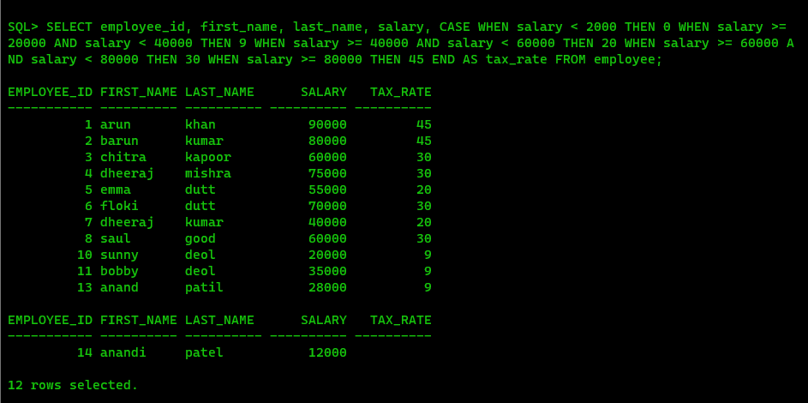

24. Find the average salary, maximum salary, minimum salary and the sum of salaries from the employee table.

🡺 SELECT AVG(salary) AS average_salary, MAX(salary) AS maximum_salary, MIN(salary) AS minimum_salary, SUM(salary) AS total_salary FROM employee;

25. Find the average salary, maximum salary, minimum salary and the sum of salaries of the

employees who work for the sales department.

🡺 SELECT AVG(salary) AS average_salary, MAX(salary) AS maximum_salary, MIN(salary) AS minimum_salary, SUM(salary) AS total_salary FROM employee WHERE dept = 'sales';

26. Find the newest and oldest employee.

🡺 SELECT MAX(doj) AS newest_employee, MIN(doj) AS oldest_employee FROM employee;

27. Find those two employees whose l_name comes first and last in alphabetical order.

🡺 SELECT MIN(last_name) AS first_employee, MAX(last_name) AS last_employee FROM employee;

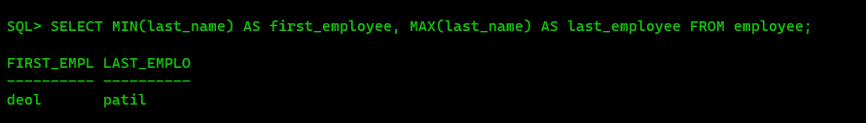

28. Find the number of engineers.

🡺 SELECT COUNT(*) AS num_engineers FROM employee WHERE job_types = 'engineer';

29. Find the number of departments from the employee table.

🡺 SELECT COUNT(DISTINCT dept) AS num_departments FROM employee;

30. Find the average commission from the employee table.

🡺 SELECT AVG(commission) AS average_commission FROM employee;

